A SPECIAL COLLOQUIUM
TO CELEBRATE
RETIREMENT AND 70TH BIRTHDAY
OF
HISASHI KOBAYASHI

Department of Electrical Engineering
School of Engineering and Applied Science
Princeton University

May 8, 2008

11: 45 am-12:45 pm: | Registration and buffet lunch
 |  |  | Friend Center Convocation Room
12:45 pm -5:30 pm: | Colloquium: Friend Center Auditorium
Colloquium Chair: Peter J. Ramadge, Professor and Chair,
Department of Electrical Engineering
12:45-1:10 pm: | Music Performance- Program 1
 | Ray Iwazumi, violin and Keiko Sekino, piano
 | Brahms-Joachim: |  | Hungarian Dance No. 6
 | Massenet: |  | 'Méditation' from the opera “Thaïs”
 | Vieuxtemps: |  | Souvenir d'Amérique (sur 'Yankee Doodle')
 | Gershwin-Heifetz: |  | “Summertime”and “A Woman Is A Sometime Thing” from the opera “Porgy and Bess”
1:10-1:20 pm: | “Welcome”
H. Vincent Poor,
Dean of the School of Engineering and Applied Science
1:20-2:00 pm: | “35 Years of Progress in Digital Magnetic Recording”
Evangelos Eleftheriou,
IBM Fellow, IBM Zurich Laboratory
2:00-2:30 pm: | “Hisashi Kobayashi at Princeton”
Brian L. Mark,
Associate Professor, George Mason University
2:30-3:00 pm: | Intermission
3:00-3:25 pm: | Music Performance- Program 2
 | Ray Iwazumi, violin and Keiko Sekino, piano
 | Kreisler: | Liebesleid
 | Kreisler: | Liebesfreud
 | Sarasate: | Fantasy on themes from Bizet’s “Carmen”
3:25-4:05 pm: | “Noise in Communication Systems: 1920s to Early 1940s”
Mischa Schwartz,
Professor Emeritus, Columbia University
4:05-4:45 pm: | “Inventing a Better Future at the MIT Media Lab”
Franklin Moss
Director, MIT Media Lab
4:45-5:25 pm: | “Trying to Build a Knowledge Based Economy”
Philip Yeo,
Chairman, SPRING Singapore
5:25-5:30 pm: | “Thank you”
 | Hisashi Kobayashi
5:30 pm: | Adjourn

ABSTRACTS AND PROFILES OF ARTISTS AND SPEAKERS

12:45 am-1:10 pm: Music Performance- Program 1
Ray Iwazumi, Violin; Keiko Sekino, Piano

Hungarian Dance No. 6 in B flat major: Vivace
by Johannes Brahms (1833-1897)/Joseph Joachim (1831-1907)

'Méditation' from the opera “Thaïs”
by Jules Massenet (1842-1912)

Souvenir d’Amérique (sur 'Yankee Doodle')
by Henri Vieuxtemps (1820-1881)

“Summertime” and “A Woman Is A Sometime Thing,”from the opera “Porgy and Bess” (1935)
by George Gershwin (1898-1937)
arranged for violin and piano by Jascha Heifetz (1901-1987)
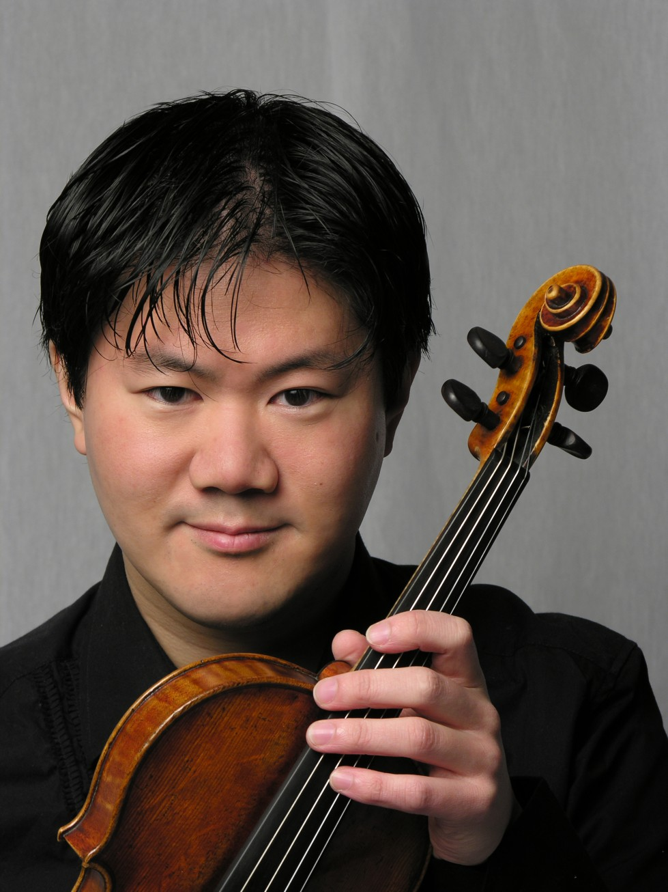
Ray Iwazumi performs in numerous concerts in the U.S. and abroad. In New York, he has given performances at Lincoln Center, appearing both in solo and chamber music at The Juilliard Theater, Alice Tully Hall, and the Donnell Library Hall. He has also been featured as a chamber musician in the Focus! Festivals, as a composer-performer in the Beyond the Machine festivals at Lincoln Center, and has been featured on several occasions on New York’s classical music radio station, WQXR-FM and wqxr.com. Centering his performing activities in New York City, Tokyo, Japan, and Brussels, Belgium, he has also performed in The Netherlands, Germany, and South Korea.
He also plays frequently in a violin duo with his sister Amy as the Ray and Amy Violin Duo, often performing in addition to established classics, his own original works and arrangements, including works for violin and electronics. He received his Bachelor, Master, and Doctor of Musical Arts degrees from The Juilliard School, where he studied with Dorothy DeLay and Hyo Kang. He also studied with Igor Oistrakh in Belgium under the auspices of a Fulbright grant.

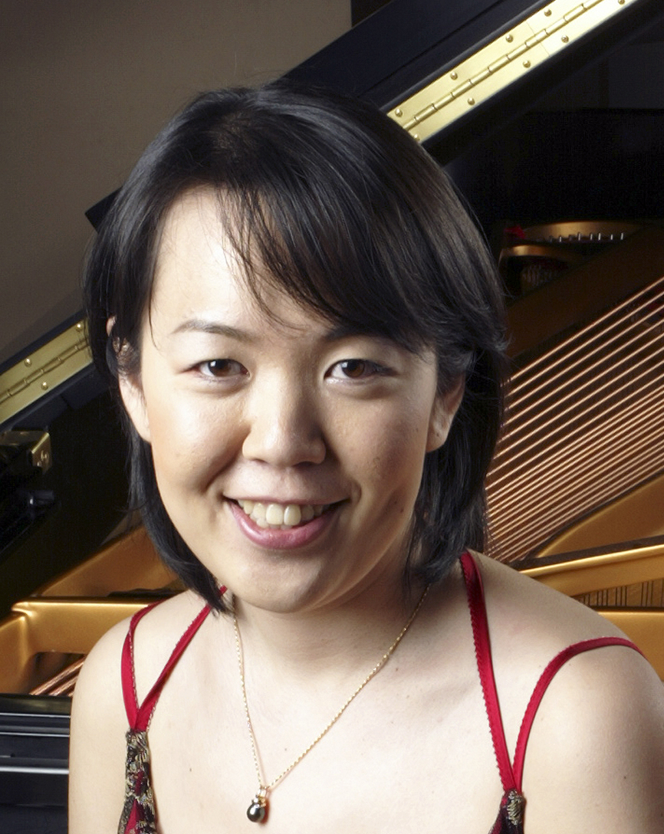
Keiko Sekino enjoys an active career as a solo recitalist and chamber musician in the United States and abroad, in recent seasons having performed at Carnegie Weill Recital Hall, Bennett-Gordon Hall at Ravinia Park, and Palacio de Festivales de Cantabria in Santander, Spain. She has participated in festivals such as Ravinia, Norfolk, and Yellow Barn in the United States and Kuhmo, Encuentro de Música y Academia de Santander, La Gesse, and Pontino in Europe. She completed a Doctor of Musical Arts degree at the Peabody Conservatory of the Johns Hopkins University and holds additional degrees from Yale University in economics and music. She is currently Assistant Professor of Piano at the East Carolina University, Greenville, NC.

1:10-1:20 pm: Welcome
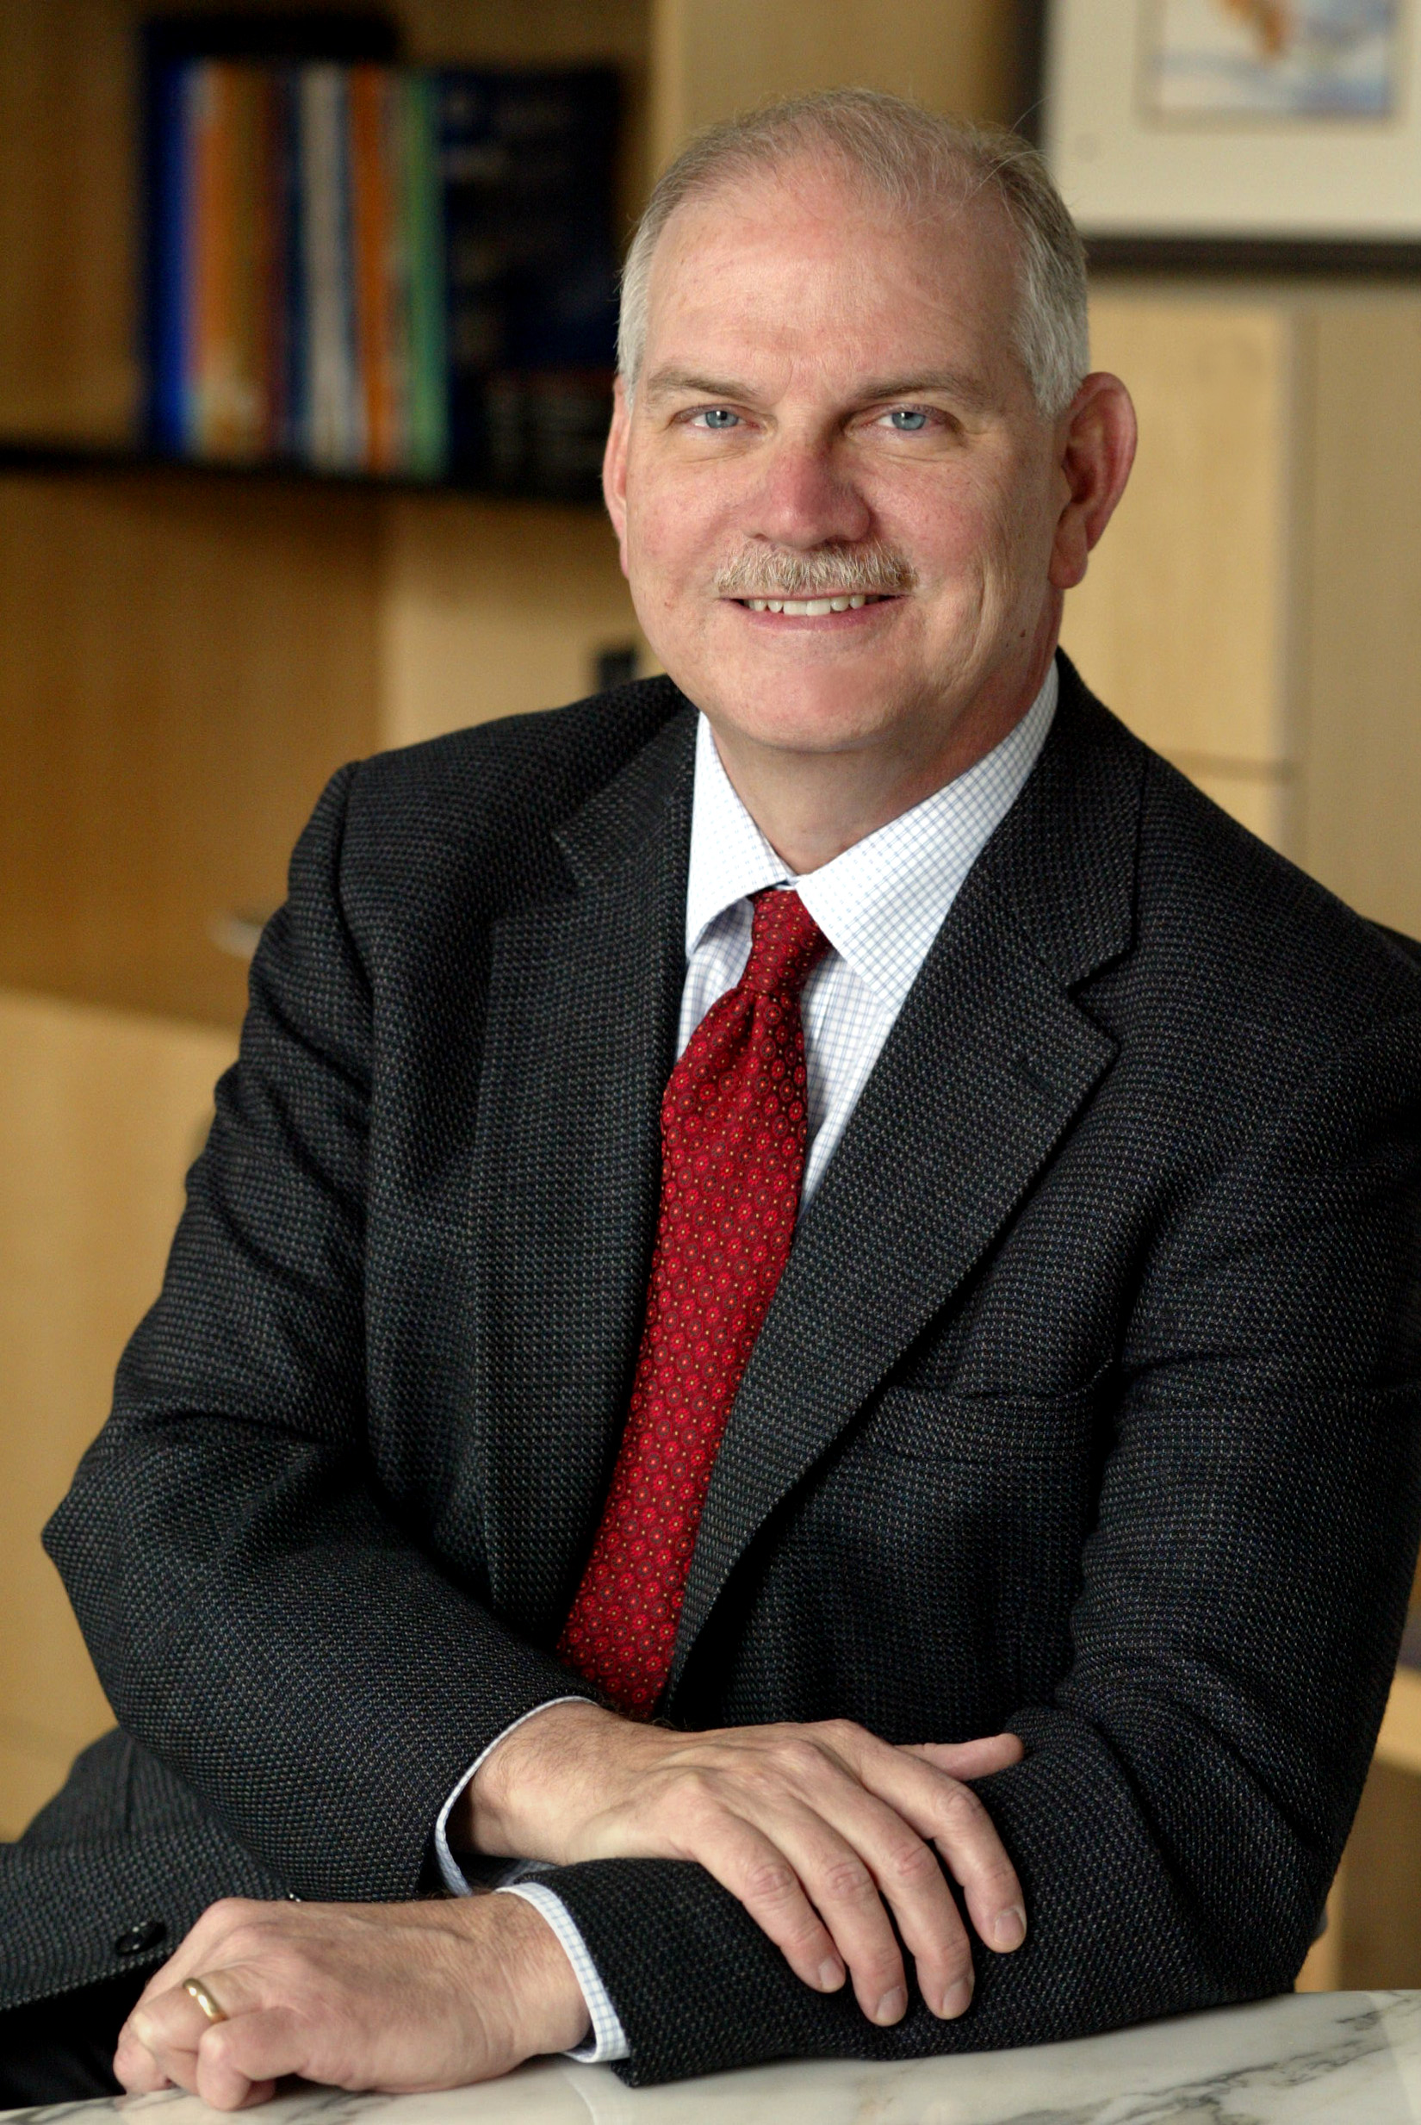
H. Vincent Poor is the Michael Henry Strater University Professor of Electrical Engineering and Dean of the School of Engineering and Applied Science at Princeton University. His primary research interests are in the area statistical signal processing, with applications in wireless networks and related fields. He is a member of the U. S. National Academy of Engineering, a Fellow of the American Academy of Arts & Sciences, and a former Guggenheim Fellow. He is also a Fellow of the IEEE, the Institute of Mathematical Statistics, and other scientific and technical organizations. He is a former President of the IEEE Information Theory Society, and a former Editor-in-Chief of the IEEE Transactions on Information Theory. Recent recognition of his work includes the 2005 IEEE Education Medal, the 2007 IEEE Marconi Prize Paper Award, and the 2007 Technical Achievement Award of the IEEE Signal Processing Society.
1:20-2:00 pm: 35 Years of Progress in Digital Magnetic Recording
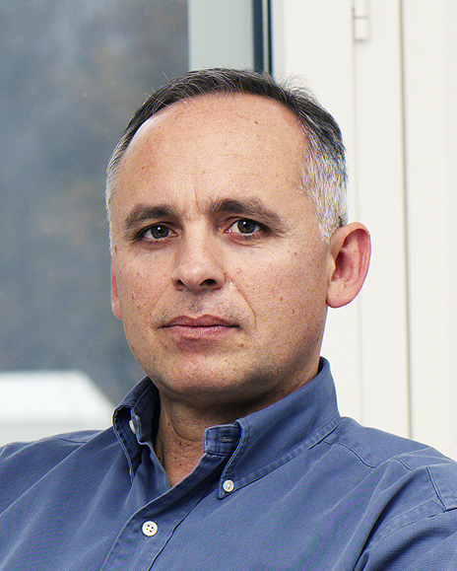
Abstract: In this presentation, we discuss the signal processing and coding technology for digital magnetic recording, the core technology of the read channel module in a hard disk drive (HDD) which processes signals read from the magnetic media. Our main focus is on the so-called PRML (partial-response, maximum-likelihood) technology, which takes advantage of the inherent redundancy in signals read out of magnetic media and whose theoretical foundation goes back to 1970. It exploits the similarities that exist between high-speed data transmission and high-density digital recording as well as between convolutional codes and partial-response shaping.
The first PRML-based read channel was introduced in HDDs in 1990, and the PRML technology soon became the first de facto industry standard for all digital magnetic recording products, ranging from HDDs to tape drives. Recently the use of the PRML technology has been extended to optical recording products, such as CDs and DVDs. Its improved version called NPML (noise-predictive, maximum-likelihood) and variants thereof have been adopted by the HDD industry since 2000. Today a read channel architecture based on NPML detection and noise-predictive parity-based post-processing techniques has become the new de facto industry standard for HDDs.
Signal processing and coding for digital recording, both magnetic and optical, is now a well established area of research and development, actively pursued by researchers in the fields of communication and information theory.
Evangelos Eleftheriou an IBM Fellow and manager of the "Storage Technologies" group at the IBM Zurich Research Laboratory. He is most known for his work on the noise-predictive maximum likelihood (NPML) architecture for the read channel of hard-disk drives. Currently, he and his team are exploring alternative storage technologies based on nanotechnology, specifically, atomic force microscopy (AFM)-based probe-storage techniques which is known internally as the "millipede" project. He has published more than 100 papers and 4 book chapters, and holds 40 US patents. He has received numerous IBM technical awards, was a co-recipient of the 2003 Leonard G. Abraham Prize of the IEEE Communications Society, and was a co-recipient of the 2005 Eduard Rhein Technology Award. He is member of the IBM Academy of Technology, and an IEEE Fellow since 2001. He received a bachelor's degree in electrical engineering from the University of Patras in Greece in 1979, and M.Eng. and Ph.D. degrees, also in electrical engineering, from Carleton University, Ottawa, Canada, in 1981 and 1985, respectively.
2:00-2:30 p.m.: Hisashi Kobayashi at Princeton
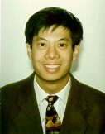
Brian L. Mark is an Associate Professor of Electrical and Computer Engineering George Mason University, where he joined in 2000. His main research interests lie in the design, modeling and performance evaluation of communication systems and networks. He received the B.ASc. (Bachelor of Applied Science) in Computer Engineering with an option in Mathematics from the University of Waterloo, Ontario, Canada in 1991, and his Ph.D. degree in Electrical Engineering from Princeton University in 1995. He was a Research Staff Member at the NEC C&C (Computers and Communications) Research Laboratories in Princeton, from 1995-1999. In 1999 he was a visiting researcher at the Ecole Nationale Supérieure des Télécommunications in Paris, France, working on the design of integrated IP/ATM networks. He received an NSF CAREER award in 2002. He is currently an Associate Editor for IEEE Transactions on Vehicular Technology. He is a co-author of a recently published textbook “System Modeling and Analysis: Foundations of System Performance Evaluation,” (Pearson/Prentice Hall, 2008).
2:00-3:00 p.m.: Intermission

3:00 -3:25 p.m.: Music Performance - Program 2
Ray Iwazumi, Violin; Keiko Sekino, Piano

Liebesleid (Sorrow of Love)
by Fritz Kreisler (1875-1962)

Liebesfreud (Joy of Love)
by Fritz Kreisler

Fantasy on themes from Bizet’s “Carmen,” Opus 25
by Pablo de Sarasate (1844-1908)

3:25-4:05 p.m.: Noise in Communication Systems: 1920's to early 1940's

Abstract: This paper discusses the early pioneering work of both telephone and radio engineers in understanding the problem of noise in communication systems, leading to improvements in the noise performance of these systems. This work led ultimately to the explosive growth of communication activities following WWII. Radio engineers during the 1920s were most concerned with reducing the impact of externally-generated “static”. Telephone engineers during that time, most prominently John R. Carson of AT&T, did, however, include the impact of “fluctuation noise” as well. Carson, in his work, even anticipated the concept of “matched filter” introduced 20 years later during radar developments of WWII. Work in the 1930s began with Armstrong’s spectacular leap ahead with his 1933 patent for noise-reducing wideband FM, followed some years later by Alex Reeves’ invention of noise-reducing PCM. These advances all focused on improving signal-to-noise ratio. We conclude by noting that it wasn’t until 1941 that communication engineers recognized that random noise was representable by Gaussian statistics!

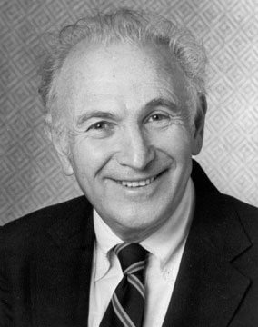
Mischa Schwartz is Charles Batchelor Professor Emeritus of Electrical Engineering, Columbia University, where he was the founding Director, in 1985, of the NSF-sponsored Center for Telecommunications Research (CTR). He is a Life Fellow of the IEEE; a member of the National Academy of Engineering, a Fellow of the AAAS, and a Fellow of the International Engineering Consortium. He is a Past President of the IEEE Communications Society as well as a former Director of the IEEE. His publications include 10 books and over 170 papers in communication theory and Systems, signal processing, wireless systems, and computer communication networks. The awards he has received include the 1984 IEEE Education Medal, the Cooper Union Gano Dunn Medal for contributions to technology, IEEE Edwin Armstrong Award for contributions to communication technology, NYC Mayor’s Award for excellence in technology, Eta Kappa Nu Eminent Member award, and the 2003 Okawa Prize for contributions to telecommunications and engineering education.

4:05-4:45 p.m.: Inventing a Better Future at the MIT Media Lab

Abstract: Today over a billion people worldwide enjoy the benefits of a digital lifestyle. But in order to meet the huge challenges faced by society in the next decade we must find radically new ways for technology to have a much deeper impact on our lives. We will describe the next big wave in technology, a “Societal Nervous System”, which is emerging as the result of advances at the intersection of the biological, physical and information sciences. This will set the stage for innovations which will transform what it means to be human, the very essence of our institutions and the architecture of our communities and cities.

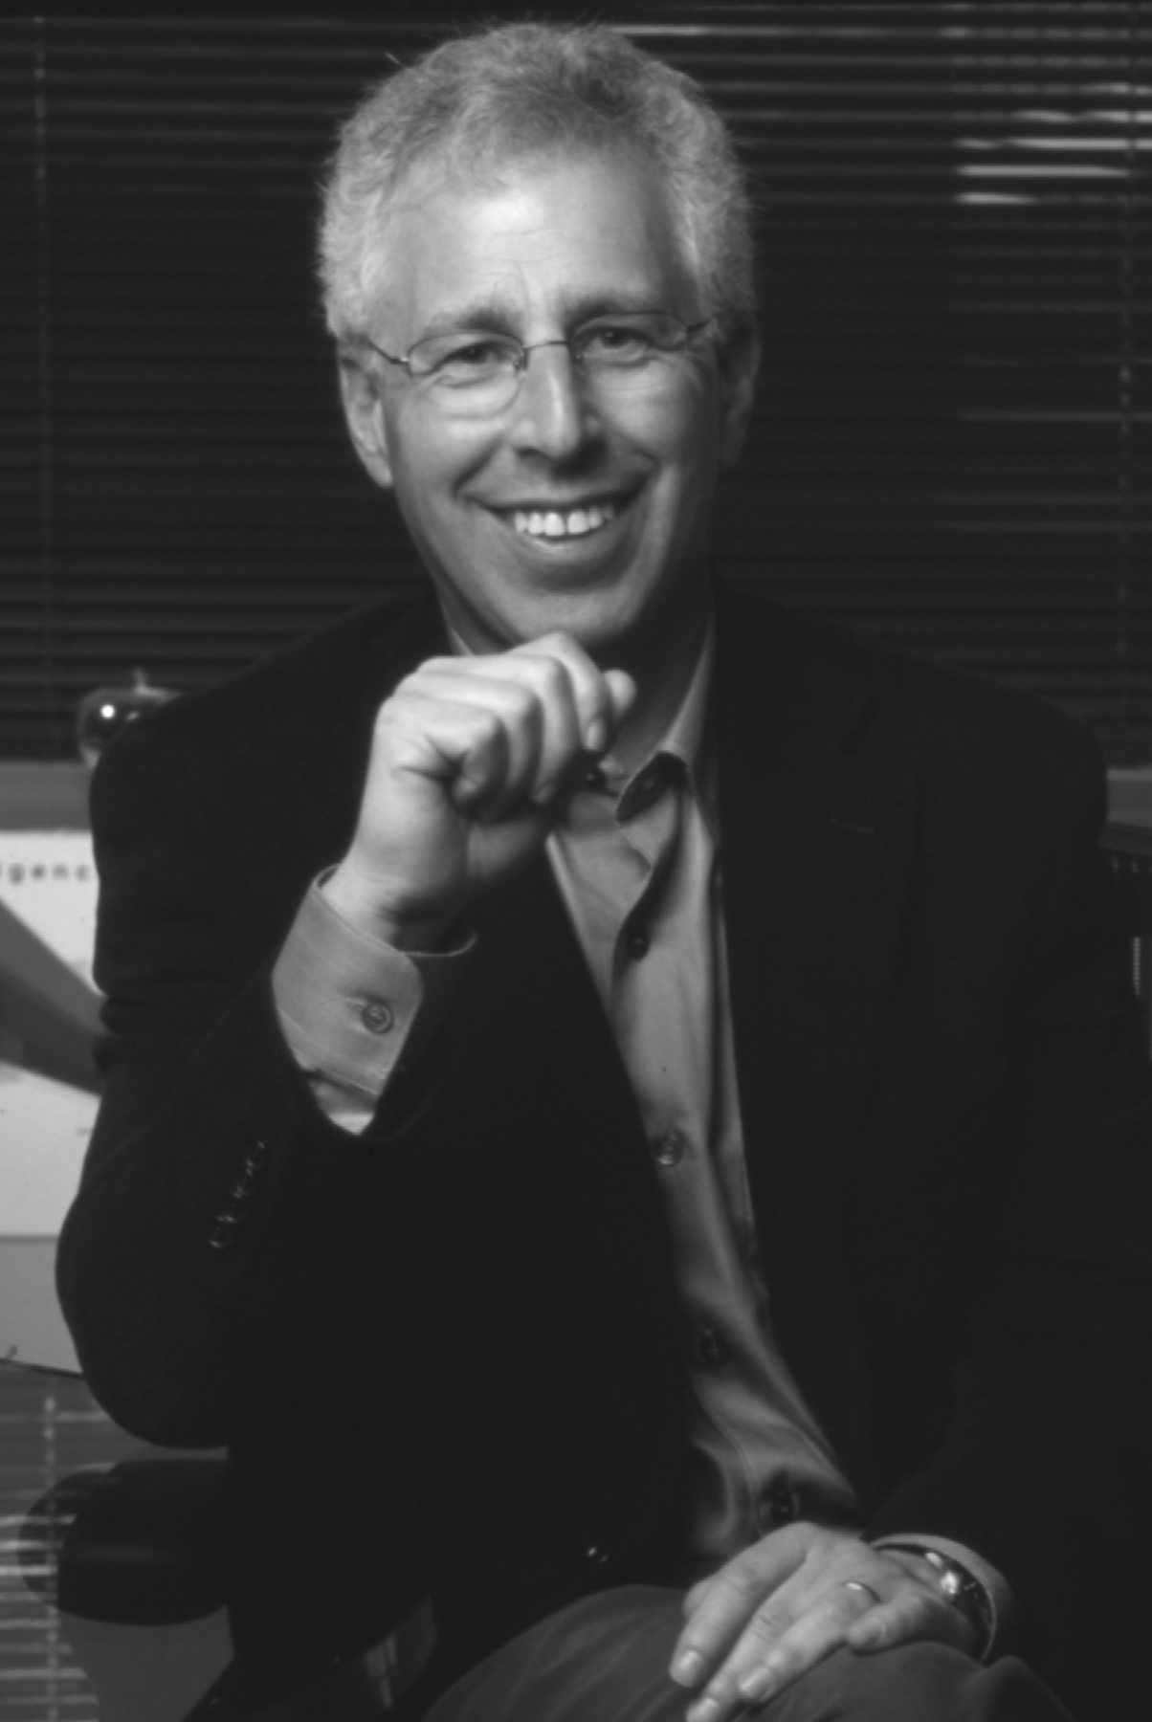
Franklin Moss is Director of the Media Lab and Wiesner Professor of Media Arts and Sciences at MIT. He received his BSE degree in aerospace and mechanical sciences from Princeton in 1971 and his MS and PhD degrees in aeronautics and astronautics from MIT. Then he joined IBM — first in Israel at the IBM Science Center and then IBM Research Center, Yorktown Heights, NY —where he led research and development projects in computer networks before launching his computer and software start-up career. His list of start-ups includes Apollo Computer, Bowstreet, Lotus Development, Stellar Computer and Tivoli Systems, which he took public in 1995 and merged with IBM in 1996. In 2001 he co-founded Infinity Pharmaceuticals, an early stage cancer drug discovery company that is now public. The honors and recognitions he received include an Ernst & Young Entrepreneur of the Year Award in 1995, Forbes magazine’s “Leaders for Tomorrow” in 2000, and Computer Reseller News’s “Top 20 Entrepreneurs to Watch for” in 2001. He is a member of the Trustees of Princeton University.

4:45-5:25 p.m.: Trying to Build a Knowledge Based Economy

Abstract: Singapore’s economic development efforts started in 1965 with an export oriented industrialization drive that targeted labor intensive activities. In the early 1980s, Singapore focused on attracting and building up skills and capital intensive industries. These efforts shifted to capability building and economic diversification throughout the 1990s. With a strong base of electronics, chemicals and engineering industries in place, Singapore began its transformation into a Knowledge Based Economy in 2000 by a focused effort on biomedical sciences. This initiative comprised a three prong strategy to develop industrial capital, intellectual capital and, most critically, human capital. Today, Singapore’s purpose built research campus, Biopolis, is home to public sector research institutes, the corporate labs of Lilly, GlaxoSmithkline and Novartis as well as the research centers of over 20 biomedical sciences companies. Leading pharmaceutical, biotechnology and medical technology players have established substantial manufacturing operations and regional headquarters in Singapore. These augur well for our efforts to build a Knowledge Based Economy even as we move into the next phase of Singapore’s biomedical sciences initiative, focused on translational research, to create and strengthen the linkages between bench and bedside.

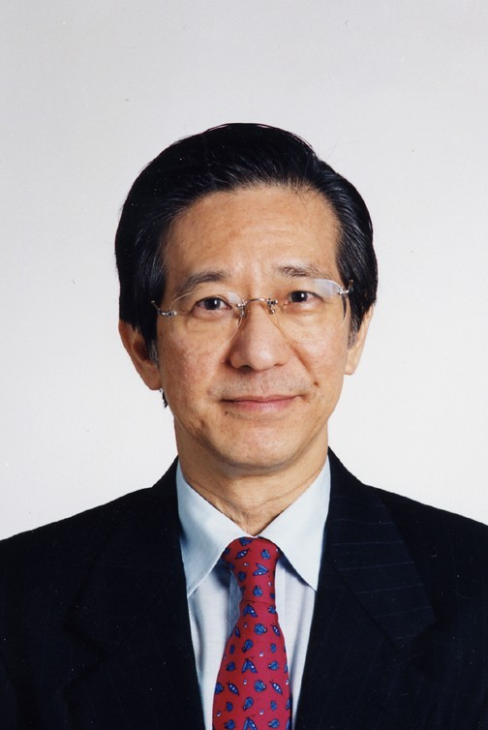
Philip Yeo is currently the Special Advisor for Economic Development (Prime Minister’s Office), Senior Advisor for Science and Technology (Ministry of Trade & Industry) and Chairman of the Standards, Productivity and Innovation Board (SPRING).
He was the Chairman of the Agency for Science, Technology and Research (A*STAR, formerly the National Science & Technology Board) from February 2001 to March 2007. Mr Yeo was formerly the Chairman of the Economic Development Board from January 1986 to January 2001 and Co-Chairman of the Economic Development Board from February 2001 to January 2006. Mr. Yeo is recognized for his contributions to Singapore’s economic development and his pioneering role in the promotion and development of the country’s information technology, semiconductor, chemical industries and biomedical sciences.

He holds a Bachelor of Applied Science (Industrial Engineering) degree and a doctorate in Engineering from the University of Toronto, Canada, Master of Science (Systems Engineering) from the then University of Singapore, and an MBA in Business Administration from Harvard University.

He has received numerous honours and awards including France’s Ordre National du Merite (National Order of Merit), Indonesia’s Bintang Jasa Utama (the First Class Order of Service Award), Belgium National Order of the Crown and the CEO Lifetime Achievement Award, Asia Pacific IPA Awards 2003, the honorary degree of Doctor of Medicine by Karolinska Institutet (2006), the 11th Nikkei Asia Prize for Science, Technology and Innovation Award (2006), the Order of the Nila Utama (First Class, one of the most prestigious Singapore National Day Awards 2006)) award and the Harvard Business School's prestigious Alumni Achievement Award 2006.

In 2007, Mr Yeo was awarded the Doctor of Science degree from Imperial College London Honoris Causa for being one of Singapore’s true pioneers of economic development in harnessing Singapore’s skills in industries such as semiconductors, aerospace, specialty chemicals and biomedical sciences and was conferred the Order of the Rising Sun, Gold and Silver Star from the Japanese Government for his significant contributions in promoting economic relations and scientific and technological cooperation between Japan and Singapore.

He is married and has a son and daughter.

Biography of Hisashi Kobayashi

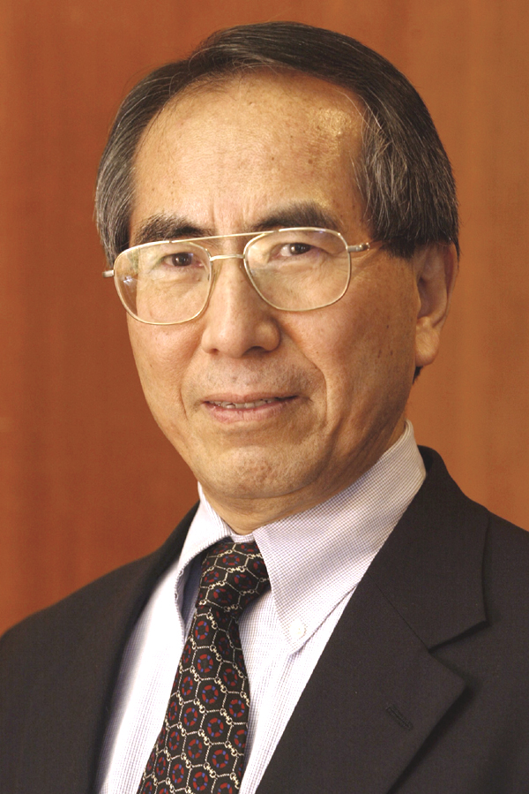
Hisashi Kobayashi has been the Sherman Fairchild University Professor of Electrical Engineering and Computer Science since 1986, when he joined the Princeton University as Dean of the School of Engineering and Applied Science (1986-91). Upon receiving his BE and ME degrees from the University of Tokyo in 1961 and 1963, respectively, he joined Radar Division of Toshiba Corp. in 1963. He came to the U.S. in 1965 as an Orson Desaix Munn Fellow of Princeton University and received his Ph.D. in 1967 and joined the IBM Research Center at Yorktown Heights, NY, where he was engaged in research of data transmission, seismic signal processing and digital magnetic recording. From 1971 till 1982 he held several managerial positions in the Computer Science Department. During his 15 years tenure with the IBM Research he took several sabbatical leaves as a visiting professor at UCLA (1969-70), University of Hawaii (1975), Stanford University (1976), Technical University of Darmstadt (1979-80), Free University of Brussels (1980).

In 1982-86, he was the founding director of IBM Japan Science Institute (later renamed IBM Tokyo Research Laboratory), and directed many research projects in computer science and manufacturing technologies. Since 1991 he has been a full time faculty member of the Electrical Engineering Department and taught graduate courses on “Communication Networks” and “Random Processes” and a senior course “Digital Communications.” He took sabbatical leaves from Princeton to the University of Tokyo (1991-92) as an NEC C&C Chair Professor, and to the University of Victoria, Canada (1998-99) as a BC ASI Fellow.

Among the honors he received are: IBM Invention Achievement Awards (1970, 1973), IBM Outstanding Contribution Awards (1974, 1984), Fellow of IEEE (1977), Senior US Scientist Award of Alexander von Humboldt Foundation, Germany (1979), IFIP (International Federation of Information Processing) Silver Core (1980), Japan’s National Academy of Engineering (1984), Life Fellow of IEEE (2003), Fellow of IEICE, Japan (2005) and the Eduard Rhein Technology Award of Germany (2005).

His professional services include: a founding member of IFIP Working Group 7.3 on Computer System Modeling (1974) and its Chairman (1982-86), the founding Editor-in-Chief of an international journal “Performance Evaluation” (1979-86), associate editor of IEEE Trans. Computers (1977-80) and IEEE Trans. Information Theory (1980-83). He also served on advisory boards of many organizations including: Department of Electrical Engineering and Computer Science (EECS) of Princeton University (1979-82), Institute of Systems Science (ISS) and Kentridge Digital Laboratory (KRDL) of Singapore (1985-2001), Advanced Systems Institute of British Columbia, Canada (1986-97), SRI International, CA (1988-91), NASA Washington, D.C. (1990-92), National Institute of Advanced Industrial Science and Technology, Japan (2001-2006), The 21st Century Center of Excellence Program, Japan (2002-2007), the Institute for Computer Sciences, Social-Informatics and Telecommunications Engineering (ICST) of Brussels (2007-), Friends of Todai (Univ. of Tokyo) Foundation, Inc. USA (2007- ) , and the National Institute of Information and Communications Technology (NICT), Japan (2008-).

He authored “Modeling and Analysis” (Addison-Wesley 1978) and most recently coauthored with Brian L. Mark, “System Modeling and Analysis: foundations of system performance evaluation” (Pearson/Prentice Hall, 2008). His second book with Prof. Mark “Probability, Random Processes and Statistical Analysis,” is scheduled to be published by Cambridge University Press in 2009.

